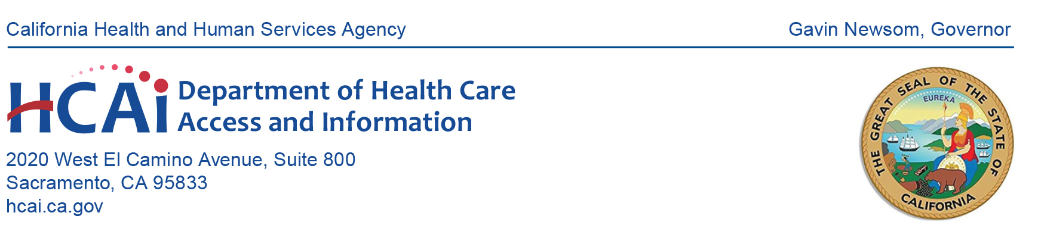
NOTICE OF MEETING:
HEALTHCARE PAYMENTS DATA (HPD) DENTAL INFORMATIONAL MEETING

Date: July 20, 2023, 10:00 a.m. – 11:00 a.m. (PDT)
Microsoft Teams Registration Link: Please email hpd@hcai.ca.gov

10:00 a.m. Welcome and Introduction
Dionne Evans-Dean, Assistant Branch Chief, HCAI
Introductions of HCAI staff and contractors.

10:05 a.m. HPD Program Overview
Suzanne Hermreck, Health Program Specialist II, HCAI
Overview of the HPD program including program goals, HPD system, and submitter types.

10:10 a.m. Dental Onboarding and Data Submission Timeline
Gina Robertson, Data Submitter Liaison, Onpoint
Overview of dental submission requirements and dental submitter onboarding timeline.

10:25 a.m. Data Collection & All-Payer Claims Database Common Data Layout (APCD-CDL™) v3.0.1
Greg Dawson, Consultant, HCAI
Overview of the data collection process and APCD-CDL™ v3.0.1

10:40 a.m. Questions & Answers Session
Dionne Evans-Dean, Assistant Branch Chief, HCAI

11:00 a.m. Adjournment

All times are estimated.

The Health Care Payments Data Program Submitter Group agenda can be viewed on the HCAI website. Meeting materials will be posted on the website by the time of the meeting. Please contact HCAI at hpd@hcai.ca.gov or at (916) 326-3829 with questions regarding the meeting.

Every effort will be made to address each agenda item as listed. However, the agenda order is tentative and subject to change without prior notice.

Pursuant to the Americans with Disabilities Act, reasonable accommodation requests may be directed at least five (5) working days in advance of this event by contacting the Health Care Payments Data Program at hpd@hcai.ca.gov.

