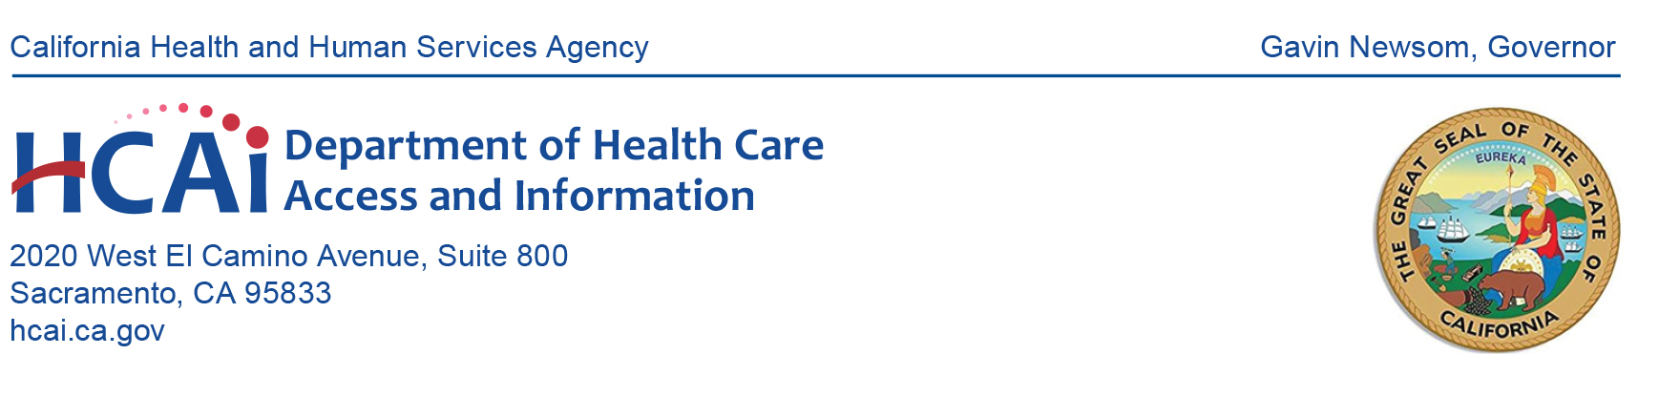**NOTICE OF MEETING**

**HEALTHCARE PAYMENTS DATA (HPD) PROGRAM SUBMITTER GROUP**

**Date: January 9, 2025**

**Time: 10:00 a.m. – 11:00 a.m. (PST)**

**Microsoft Teams**

10:00 a.m. **Welcome and New Team Member Introduction**

*Anna Dito; Cost Transparency Section Manager, HCAI*

10:05 a.m. **Key Program Updates**

*Jasmine Neeley; Healthcare Payments Data Unit, HCAI*

10:10 a.m. **Status of Production File Submissions**

*Benson Zheng, HPD Unit, HCAI*

10:15 a.m. **Registration – What is New and What is Available**

*Jasmine Neeley, HPD Unit, HCAI; Nicole Jakubowski, Onpoint Data*

*Operations Analyst and Dawn Hamlin, Onpoint Data Operations Manager*

10:50 a.m. **Q&A – Open Forum**

10:55 a.m. **Program Reminders**

*Suzanne Hermreck, Cost Transparency Section, HCAI*

Upcoming meetings and HPD resources.

11:00 a.m. **Adjournment**

**All times are estimated.**

Submitter group meeting materials will be posted on the [HPD website](https://hcai.ca.gov/data-and-reports/cost-transparency/healthcare-payments/health-care-payments-data-program-submitters/) by the time of the meeting. Please contact HCAI at [hpd@hcai.ca.gov](mailto:hpd@hcai.ca.gov) or at (916) 326-3829 with questions regarding this meeting.

Every effort will be made to address each agenda item as listed. However, the agenda order is tentative and subject to change without prior notice. Pursuant to the Americans with Disabilities Act, reasonable accommodation requests may be directed at least five (5) working days in advance of this event by contacting [hpd@hcai.ca.gov](mailto:hpd@hcai.ca.gov).