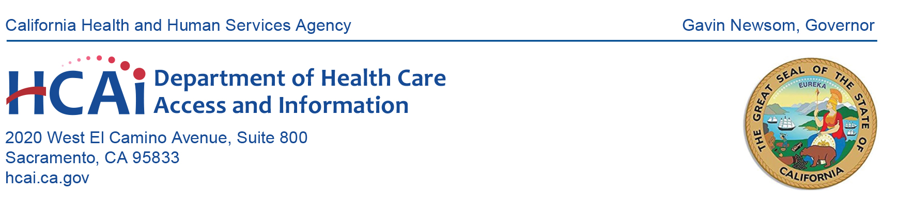
NOTICE OF MEETING
HEALTHCARE PAYMENTS DATA (HPD) PROGRAM SUBMITTER GROUP

Date: January 9, 2025
Time: 10:00 a.m. – 11:00 a.m. (PST)
Microsoft Teams

10:00 a.m. Welcome and New Team Member Introduction
Anna Dito; Cost Transparency Section Manager, HCAI

10:05 a.m. Key Program Updates
Jasmine Neeley; Healthcare Payments Data Unit, HCAI

10:10 a.m. Status of Production File Submissions
Benson Zheng, HPD Unit, HCAI

10:15 a.m. Registration – What is New and What is Available
Jasmine Neeley, HPD Unit, HCAI; Nicole Jakubowski, Onpoint Data
Operations Analyst and Dawn Hamlin, Onpoint Data Operations Manager

10:50 a.m. Q&A – Open Forum

10:55 a.m. Program Reminders
Suzanne Hermreck, Cost Transparency Section, HCAI
Upcoming meetings and HPD resources.

11:00 a.m. Adjournment

All times are estimated.

Submitter group meeting materials will be posted on the HPD website by the time of the meeting. Please contact HCAI at hpd@hcai.ca.gov or at (916) 326-3829 with questions regarding this meeting.

Every effort will be made to address each agenda item as listed. However, the agenda order is tentative and subject to change without prior notice. Pursuant to the Americans with Disabilities Act, reasonable accommodation requests may be directed at least five (5) working days in advance of this event by contacting hpd@hcai.ca.gov.

