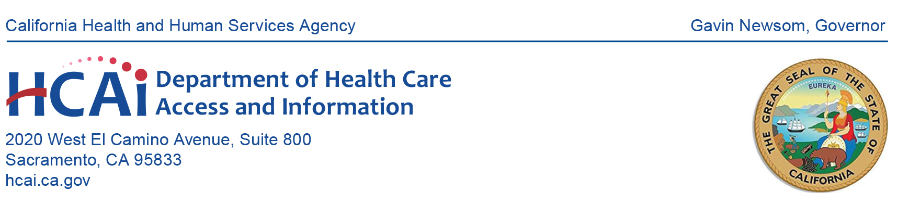**NOTICE OF MEETING**

**HEALTHCARE PAYMENTS DATA (HPD) PROGRAM SUBMITTER GROUP**

**Date: January 11, 2024**

**Time: 10:00 a.m. – 11:00 a.m. (PST)**

**Microsoft Teams** [**registration link**](https://events.gcc.teams.microsoft.com/event/851832a0-ca61-4cc4-b1d0-efb1a828a9a8@28891a93-888f-489f-9930-e78b8f733ca6)

10:00 a.m. **Welcome and Key Program Updates**

*Dionne Evans-Dean, Enterprise Data Operations Branch, HCAI*

Introduction of New HPD staff, Review HPD Timeline 2024-2025 and Key Deadlines, Regulations Update, and HPD Committee Updates.

10:05 a.m. **Status of Production File Submissions**

*Jenny Chi, HPD Unit, HCAI*

Presentation on the status of production file submissions to HPD.

10:10 a.m. **Data Quality and Completeness**

*Ertug Misirli, HPD Unit, HCAI*

Data Completeness Updates and Workplan for data quality reports for Plans.

10:15 a.m. **Dental Data Overview and Implementation**

*Carolyne Conrad, Gina Robertson, Nicole Jakubowski, Dawn Hamlin*

*Onpoint Health Data*

Dental plan registration, dental plan submitter registration, and documentation.

10:55 a.m. **Program Reminders**

*Sherry Mung & Suzanne Hermreck, Cost Transparency Section, HCAI*

Non-claims Payments Regulations, upcoming meetings and HPD resources.

11:00 a.m. **Adjournment**

**All times are estimated.**

The HPD Program Submitter Group agenda can be viewed on the [HCAI website](https://hcai.ca.gov/data-and-reports/cost-transparency/healthcare-payments/health-care-payments-data-program-submitters/). Meeting materials will be posted on the website by the time of the meeting. Please contact HCAI at [hpd@hcai.ca.gov](mailto:hpd@hcai.ca.gov) or at (916) 326-3829 with questions regarding the meeting.

Every effort will be made to address each agenda item as listed. However, the agenda order is tentative and subject to change without prior notice.

Pursuant to the Americans with Disabilities Act, reasonable accommodation requests may be directed at least five (5) working days in advance of this event by contacting [hpd@hcai.ca.gov](mailto:hpd@hcai.ca.gov).