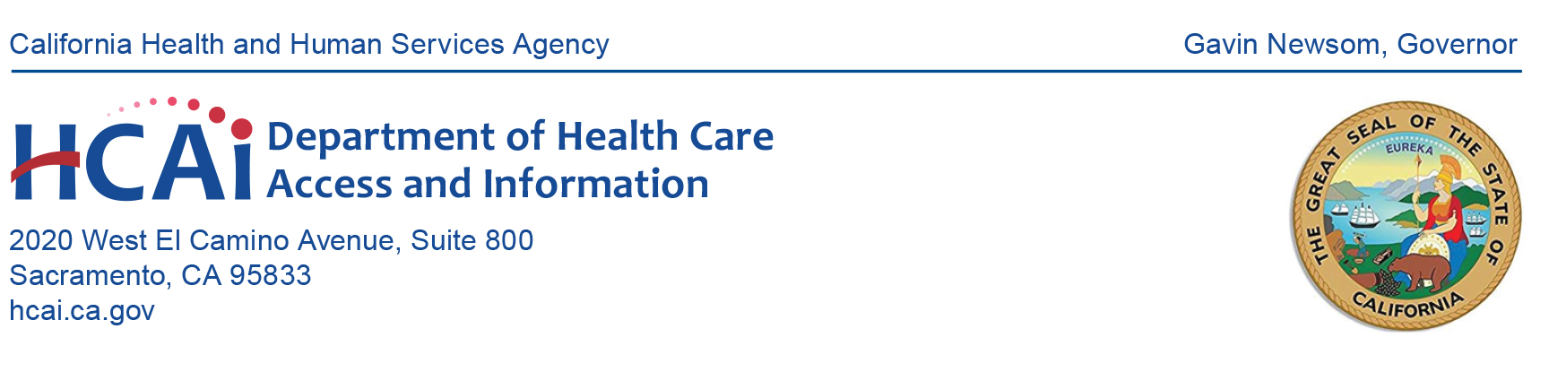
July 12, 2022
Meeting Minutes

CALIFORNIA HEALTH WORKFORCE EDUCATION
AND TRAINING COUNCIL
(Council)

***SPECIAL NOTICE***
The California Health Workforce Education and Training Council held its meeting remotely as authorized by Section 11133 of the Government Code.
Council Members Present  Sandra Baker, DNP, RN, CNE, ANEF  Audrey Dow, MA  Kathryn Dresslar  Katherine Flores, MD  Kevin Grumbach, MD  Yingjia Huang, MPP  Catherine Kennedy, RN  Roger Liu, PhD  Judith Lui, RN MSN  Nader Nadershahi, DDS, MBA, EdD  Cedric Rutland, MD  Sandra Sanchez, MBA  Abby Snay, M,Ed  Vernita Todd, MBA  Van Ton-Quinlivan, MBA  Council Members Not in Attendance  Sylvia Alva, PhD  Carrie Byington, MD  Catherine Kennedy, RN | . | HCAI Director  Elizabeth Landsberg  HCAI Staff Jean-Paul Buchanan  Hovik Khosrovian  Ross Lallian  Caryn Rizell

AGENDA ITEM 1: Call to Order
Chair Baker called the meeting to order at 10:04 a.m.

AGENDA ITEM 2: Introduction of Council Members and Oath of Office
Council members introduced themselves. HCAI Legal administered the Oath of Office to Abby Snay and Vernita Todd.

AGENDA ITEM 3: HCAI Director Remarks
Elizabeth Landsberg, Director, HCAI, provided an overview of the Fiscal Year (FY) 2022-23 state budget, noting that this budget continues to expand HCAIs role in health workforce programs and includes several other new investments. These include the formation of the Office of Health Care Affordability, the CalRX project, and funding to support access to reproductive healthcare services.

She reiterated that there is a workforce crisis in California and substantial funding to help support workforce development, and that the Council has an important role in assisting HCAI with developing innovative and effective approaches to solving workforce challenges.

AGENDA ITEM 4: HCAI Workforce Updates
Caryn Rizell, Deputy Director, Healthcare Workforce Development, HCAI, updated the Council on health workforce program activities accomplished in the last year. In addition, she provided a comprehensive overview of the historic investments in health workforce in the FY 2022-23 budget.

Ross Lallian, Research Section Chief, Healthcare Workforce Development, HCAI, provided an update on work related to the Health Workforce Research Data Center.

AGENDA ITEM 5: Approval of March 30 Meeting Minutes and Disposal of Meeting Recordings
The Council reviewed the March 30, 2022, Council Meeting Minutes. HCAI Legal provided information on the disposal of meeting recordings and any impact.

PUBLIC COMMENT
Request to wait to delete recordings until public can request copies and for HCAI to publish transcripts to support the recording.

ACTION ITEM
Motion to approve the March 30, 2022, Council Meeting Minutes (Baker), second (Grumbach). Motion approved with two abstentions, Snay and Todd.

Motion to approve the disposal of the March 30, 2022, Council meeting recording (Baker), second (Flores). Motion approved.

The March 30, 2022, Council Meeting Minutes are hereby incorporated as Attachment A.

AGENDA ITEM 6: Next Council Meeting and Subcommittee Update
Hovik Khosrovian, Policy Section Chief, Healthcare Workforce Development, HCAI, recommended a quarterly schedule for Council meetings and provided dates through the end of 2022. He also proposed expanding Council meetings to two days. The day one meeting themes will focus on Behavioral Health, Nursing, General Medical Education, and Allied Health and include information about current and new HCAI funding. Day two meetings will expand on day one themes and dive deeper into those topics. The second day meetings are optional for Council members.

The Council requested that HCAI staff develop the meeting calendar for 2023 and present at the next Council meeting.

PUBLIC COMMENT
- Support the revised approach and recommendation on the structure of day one and two meetings. This breaks down traditional silos by allowing anyone to participate.
- Does not agree with the September dates due to schedule conflict.

ACTION ITEM
Motion to approve quarterly Council Meetings (Baker), second (Dresslar). Motion approved.

Motion to approve the 2022 Council Meeting dates as proposed (Baker), second (Huang). Motion to approve with one no vote, Sanchez.

Next Council Meeting and Subcommittee Update presentation is hereby incorporated as Attachment B.

AGENDA ITEM 7: Robert’s Rules of Order and Public Meeting Requirements
Jean-Paul Buchanan, Attorney, HCAI, presented on Robert’s Rules of Order for meetings and public meeting requirements. .

The Robert’s Rules of Order and Public Meeting Requirements presentation is hereby incorporated as Attachment C.

AGENDA ITEM 8: The State of the Behavioral Health Workforce in California
Janet Coffman, PhD, MPP, MA, UCSF HealthForce Center, presented on the behavioral health workforce in California, including behavioral health occupation data, the behavioral health workforce pipeline, and offered recommendations for the Council and HCAI to consider.

The Behavioral Health presentation is hereby incorporated as Attachment D.

AGENDA ITEM 9: Discussion on Behavioral Health Workforce and Training
The Council Chair and Vice-Chair facilitated a discussion on the behavioral health workforce. The discussion focused on how to increase the supply and diversity of the behavioral health workforce through innovative ideas for new programs, improvements for existing programs, and considerations for new funding.

HCAI staff will present key takeaways and common themes from the discussion and introduce a behavioral health topic for discussion at the September Council meeting.

AGENDA ITEM 10: General Public Comment
- Recommend integrating primary care with behavioral health.
- Reach out to diverse communities to identify barriers and the need to develop programs or offer stipends/wrap-around supports to address these barriers.
- Develop awareness to address the stigma around mental health in primary care and in the student community.
- Offer mentoring and other support for students at risk of not completing their program or to bring them back to complete their program
- Consider investments to support Community Health Centers to retain instructors and to train students.

AGENDA ITEM 12: Adjourn Meeting

The meeting adjourned at 3:17 p.m. on July 12, 2022.

